MODEL DEVELOPMENT DOCUMENT
Predictive Maintenance
Machine Failure Prediction using Supervised Machine Learning

Requested by | IOT Academy
Created by | Samruddhi Mulmule
Project | Capstone Project 1 – Predictive Maintenance
Data source | predictive_maintenance.csv (10,000 records, 9 columns)
Final model | Tuned XGBoost classifier (StandardScaler + SMOTE training pipeline)
Document version | 1.0
Date | 25 October 2026

This document describes how the machine-failure prediction model was developed and justifies every step of the work, from understanding the data to deploying the model in a web application.

Table of Contents
1. Title of the Project 3
2. Brief on the Project 3
3. Deliverables of the Project 3
4. Resources 4
5. Individual Details 6
6. Milestones 6
7. Data Understanding and Quality Checks 6
8. Exploratory Data Analysis (EDA) 7
9. Feature Engineering and Feature Selection 9
10. Skewness and Outlier Treatment 10
11. Data Preparation for Modelling 11
12. Model Development and Comparison 12
13. Overfitting Analysis and Treatment 13
14. Final Model Selection and Evaluation 14
15. Model Deployment 15
16. Limitations 16
17. Conclusion 16
Appendix A: Step-by-Step Justification Summary 16
Appendix B: Glossary of Terms 17

1. Title of the Project
Predictive Maintenance – Predicting Machine Failure from Sensor Data using Supervised Machine Learning Classification
The project is named Predictive Maintenance and was requested by IOT Academy. It was created by Samruddhi Mulmule. The title describes what the final model does: it reads the sensor values of a machine and classifies whether the machine will fail (class 1) or keep working (class 0).

2. Brief on the Project

2.1 Project type
Supervised machine learning, binary classification on structured (tabular) data. The target column is Target (0 = no failure, 1 = failure). It is also an imbalanced-classification problem, because only 3.39% of the records are failures.

2.2 Problem addressed
The goal is to build a machine learning model that predicts, from real-time sensor data, whether a machine is likely to fail. The model should support predictive-maintenance strategies that reduce downtime, improve efficiency and lower operating cost. The objective is to build classification models, compare their performance and select the best one.

2.3 Motivation
Unplanned machine failure stops production, damages tools and costs money, while servicing machines too early wastes time and parts. A model that warns of a likely failure lets maintenance be planned at the right time. The problem is also technically interesting: failures are rare (339 of 10,000 records), so a model that always predicts “no failure” would be 96.61% accurate yet completely useless. This forces the use of proper metrics (precision, recall, F1, PR-AUC) and of imbalance handling.

2.4 Tentative approach
- Load and inspect the data; check missing values, duplicates and data types.
- Explore the data visually (EDA) to find which readings separate failed from healthy machines.
- Create physically meaningful features and decide which features to keep.
- Treat skewed variables and decide how to handle outliers.
- Split the data (stratified), scale it and balance the classes with SMOTE inside a pipeline.
- Train nine classification algorithms and compare them with cross-validation.
- Check overfitting, tune the best model and evaluate it once on a hold-out test set.
- Save the model and serve it through a Streamlit web application.

3. Deliverables of the Project

3.1 General approach and evaluation plan
The problem is solved through experiments on the data. Evidence is gathered in four ways:
- Hold-out test set: 20% of the data (stratified) is kept untouched until the final evaluation.
- Cross-validation: 5-fold stratified cross-validation on the training set is used to compare models and to tune the best one, so the test set never influences model choice.
- Metrics for the failure class: precision, recall, F1, ROC-AUC and PR-AUC. Accuracy is reported only for reference because of the 96.61% / 3.39% class split.
- Diagnostics: train vs cross-validation vs test F1 (overfitting check), confusion matrix and ROC curve.

3.2 Questions the model and project are designed to answer
- Can sensor readings predict whether a machine will fail?
- Which readings differ most between failed and healthy machines?
- Does the machine type (L, M, H) influence the failure rate?
- Do features that combine sensor readings (temperature difference, power, torque × wear) improve the model?
- How should the severe class imbalance be handled without leaking information?
- Which of the nine algorithms predicts failures best?
- Is the final model overfitted and how was this treated?
- How many real failures does the final model catch, and how many of its alarms are correct?
- How can a non-technical user obtain a prediction for a new machine?

3.3 Model details, important findings, expected observations and outcome
Table 1: Summary of the final model
Final model | XGBoost classifier, trained in the pipeline StandardScaler → SMOTE → XGBClassifier
Best settings | learning_rate = 0.2, max_depth = 4, n_estimators = 300 (GridSearchCV, 5-fold, scoring F1)
Input features (10) | Air_temp, Process_temp, Rot_speed (log1p), Torque, Tool_wear, Temp_diff, Power, Torque_wear, Type_L, Type_M
Cross-validation F1 | 0.809 (default XGBoost: 0.796)
Test-set result | Accuracy 0.984 | Precision 0.743 | Recall 0.809 | F1 0.775 | ROC-AUC 0.981
Confusion matrix (test) | True failures caught 55, missed 13; false alarms 19; correctly cleared machines 1,913
Table 2: Expected observations versus actual outcome
Expectation | What the project found
Failed machines show higher torque and tool wear | Confirmed: average torque 50.2 vs 39.6 Nm and tool wear 143.8 vs 106.7 min (failed vs healthy)
Class imbalance makes accuracy misleading | Confirmed: always predicting “no failure” gives 96.61% accuracy
Tree ensembles beat linear and distance-based models | Confirmed: XGBoost (F1 0.796) and Random Forest (0.746) lead; Logistic Regression (0.270) and Naive Bayes (0.261) are lowest
Engineered features help | Confirmed: cross-validation F1 rises for all five models tested (up to +0.116)
Tuning improves generalisation | Partly: test F1 0.727 → 0.775 and train–test gap 0.273 → 0.222, but some overfitting remains

4. Resources

4.1 Data set source
The data file is predictive_maintenance.csv, supplied with the project description from IOT Academy. It corresponds to the Kaggle dataset Machine Predictive Maintenance Classification. Size and failure rate match: 10,000 rows and 339 failures (3.39%). The Kaggle version has 10 columns, including a separate Failure Type column; the project file has the 9 columns listed in Section 4.2 and does not contain Failure Type, which is correct because it would reveal the target directly.
Table 3: Data set facts
File name | predictive_maintenance.csv
Size | 10,000 records × 9 columns; 0 missing values; 0 duplicate rows
Target | Target: 9,661 records with no failure (96.61%) and 339 failures (3.39%)
Kaggle link | https://www.kaggle.com/datasets/shivamb/machine-predictive-maintenance-classification
Note: the project description mentions 21 records, but the supplied file contains 10,000 (verified with df.shape = (10000, 9)). All results in this document use the 10,000 records.

4.2 Data dictionary
Table 4: Columns of predictive_maintenance.csv
Original column | Name in code | Description | Data type | Observed values | Role in model
UDI | UDI | Unique identifier of each record | Integer (ID) | 1 – 10,000 | Dropped
Product ID | Product_ID | Product identifier (letter + serial number) | String | 10,000 unique | Dropped
Type | Type | Machine type: Low, Medium, High | Categorical | L 6,000; M 2,997; H 1,003 | Feature (one-hot)
Air temperature [K] | Air_temp | Surrounding air temperature (Kelvin) | Float | 295.3 – 304.5 | Feature
Process temperature [K] | Process_temp | Process temperature (Kelvin) | Float | 305.7 – 313.8 | Feature
Rotational speed [rpm] | Rot_speed | Rotation speed (revolutions per minute) | Integer | 1,168 – 2,886 | Feature (log1p)
Torque [Nm] | Torque | Torque produced (Newton-metres) | Float | 3.8 – 76.6 | Feature
Tool wear [min] | Tool_wear | Tool wear (minutes of use) | Integer | 0 – 253 | Feature
Target | Target | Failure indicator (0 = no, 1 = yes) | Binary | 0: 9,661; 1: 339 | Target
Table 5: Features created during the project
New feature | Formula | Meaning | Correlation with Target
Temp_diff | Process_temp − Air_temp | Heat dissipation of the process | −0.112
Power | Torque × Rot_speed × 2π / 60 (watts) | Mechanical power of the machine | 0.176
Torque_wear | Torque × Tool_wear | Overstrain indicator | 0.190

4.3 Software
Table 6: Software used
Software | Purpose in this project
Python 3.12 / Jupyter Notebook | Programming platform for the whole analysis (Predictive_Maintenance_Project.ipynb)
pandas, NumPy, matplotlib, seaborn | Data loading, cleaning and transformation; EDA and result visualisations
scikit-learn | Train/test split, scaling, nine classifiers, cross-validation, GridSearchCV and metrics
imbalanced-learn | SMOTE oversampling and the pipeline that applies it only to training data
XGBoost | Final gradient-boosting classifier
pickle, Streamlit | Saving the model and serving predictions through a web application (app.py)
Claude (Anthropic) | AI assistant used for guidance.

5. Individual Details
Table 7: Individual details
Name | Samruddhi Mulmule
E-mail ID | samruddhimulmule@gmail.com
Phone number | +91 8983225563
Programme / requested by | IOT Academy – Capstone Project 1
Role | Creator and author of the project and of this document

6. Milestones
Table 8: Project milestones and status
Milestone | What was done | Status | Section
Define a problem | Binary classification: predict whether a machine fails (Target) | Completed | 2, 3
Understanding the business problem | Predictive maintenance reduces downtime and cost; failures are rare, so recall and precision matter | Completed | 2.3, 11.5
Get the Data | predictive_maintenance.csv loaded (10,000 × 9) | Completed | 4.1, 7
Explore and pre-process data | Quality checks, column renaming, ID removal, skewness and outlier analysis, encoding | Completed | 7, 10
Choosing the python platform | Python 3.12 in Jupyter with scikit-learn, imbalanced-learn and XGBoost | Completed | 4.3
Create Features | Three engineered features; feature selection decisions | Completed | 9
EDA | Target, type, distributions, box plots and correlations | Completed | 8
Create Model | Nine algorithms, SMOTE pipeline, tuning of XGBoost | Completed | 11, 12, 13
Model Evaluation | Cross-validation, test evaluation, overfitting check, confusion matrix, ROC | Completed | 12, 13, 14
Report Writing | This Model Development Document (version 1.0) | Completed | All
Project submission | Submission of notebook, document and application to IOT Academy | Ready | –

7. Data Understanding and Quality Checks
The data was loaded with pandas (read_csv) and checked before any modelling. The column names were shortened (for example “Air temperature [K]” became Air_temp) because spaces and brackets are awkward in code and the XGBoost library does not accept brackets in feature names.
Table 9: Data quality checks
Check | Result | Decision and justification
Shape | 10,000 rows × 9 columns | Enough rows for 5-fold cross-validation, but only 339 failures
Data types | 4 integer, 3 float, 2 text columns | Numeric columns are model-ready; Type needs encoding
Missing values | 0 in every column | No imputation needed, so no bias is introduced
Duplicate rows | 0 | No rows removed
Unique values | UDI 10,000; Product_ID 10,000; Type 3; Target 2 | UDI and Product_ID are unique per row, so they are identifiers
Summary statistics were reviewed with describe(). All readings lie in plausible ranges, and the mean of Target is 0.0339, i.e. 3.39% failures.
Table 10: Summary statistics of the numeric columns
Column | Mean | Std. dev. | Min | Median | Max
Air_temp | 300.00 | 2.00 | 295.3 | 300.1 | 304.5
Process_temp | 310.01 | 1.48 | 305.7 | 310.1 | 313.8
Rot_speed | 1,538.78 | 179.28 | 1,168 | 1,503 | 2,886
Torque | 39.99 | 9.97 | 3.8 | 40.1 | 76.6
Tool_wear | 107.95 | 63.65 | 0 | 108 | 253

Why UDI and Product_ID are dropped: Both values are different for every row, so they contain no pattern that can be applied to new machines. Keeping them would only let a model memorise individual rows. The first letter of Product_ID also repeats the information already stored in Type.

8. Exploratory Data Analysis (EDA)
EDA was carried out to understand the target, find which readings relate to failure and decide on the later preparation steps.

8.1 Target distribution and machine type
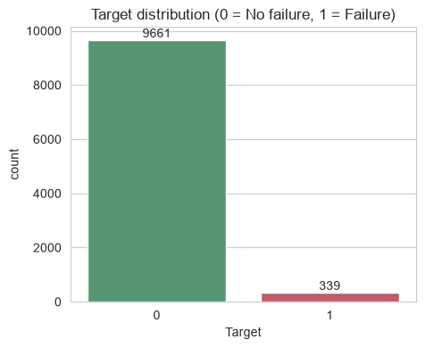  Figure 1: Target distribution | 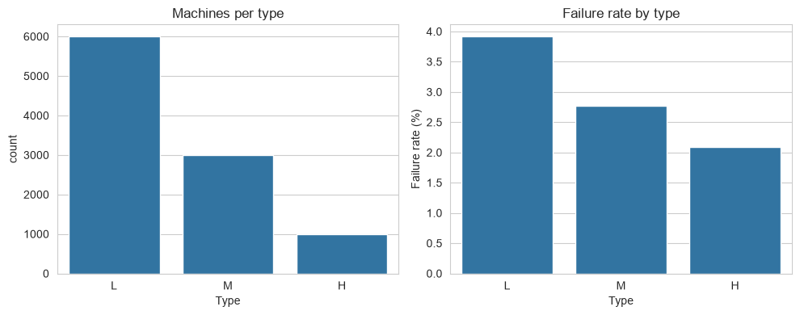  Figure 2: Machine type and failure rate
Only 3.39% of the machines fail (339 of 10,000). Justification: the data is highly imbalanced, so accuracy cannot be trusted and the project uses recall, precision, F1 and PR-AUC, and treats the imbalance (Section 11). The failure rate also depends on machine type: L 3.92% (235 of 6,000), M 2.77% (83 of 2,997) and H 2.09% (21 of 1,003). Type therefore carries information and is kept as a feature.

8.2 Distribution of the numeric features
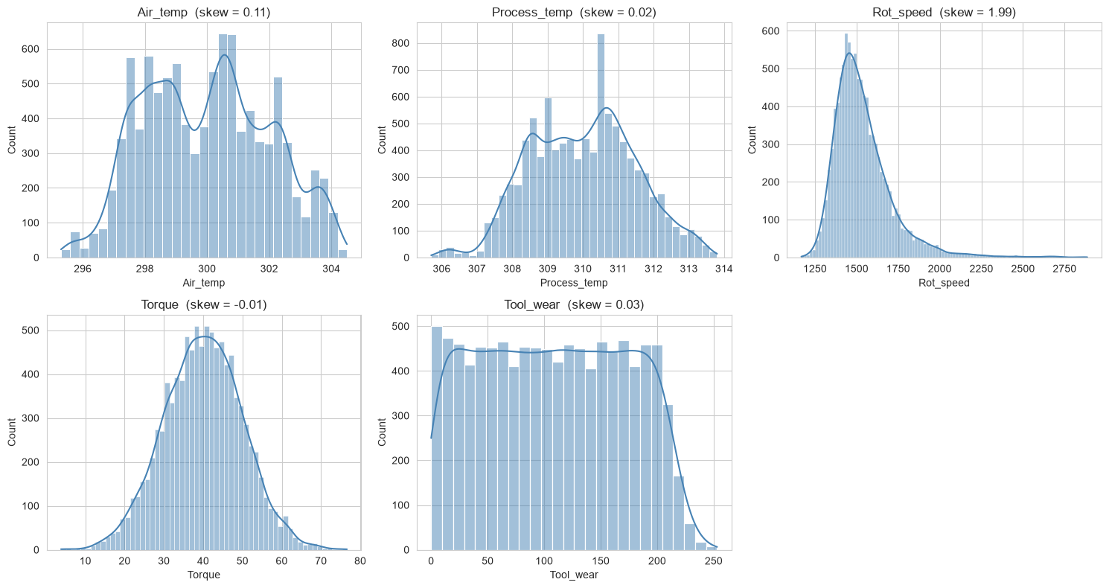
Figure 3: Histograms with skewness of the five numeric features
Air_temp, Process_temp, Torque and Tool_wear are close to symmetric (skewness near 0). Rot_speed is right-skewed (skewness 1.99) and is treated in Section 10.

8.3 Failed versus healthy machines
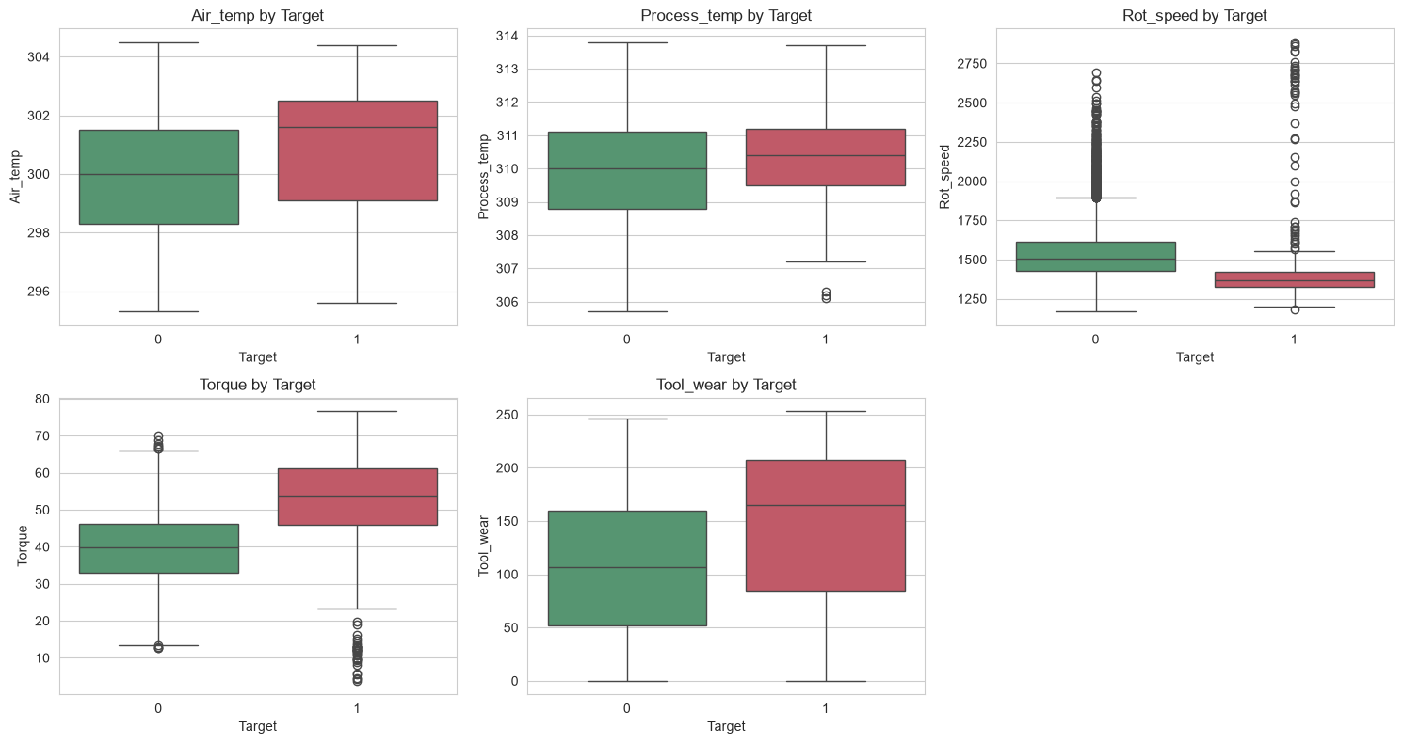
Figure 4: Box plots of each feature for healthy (0) and failed (1) machines
Table 11: Average readings by machine status
Reading | No failure (0) | Failure (1) | Difference
Torque [Nm] | 39.6 | 50.2 | Higher for failures
Tool wear [min] | 106.7 | 143.8 | Higher for failures
Rotational speed [rpm] | 1,540.3 | 1,496.5 | Lower for failures
Failed machines have higher torque, higher tool wear and lower rotational speed, and they show more outliers. Justification: these readings are the main drivers of failure and are combined into engineered features (Section 9).

8.4 Correlation analysis
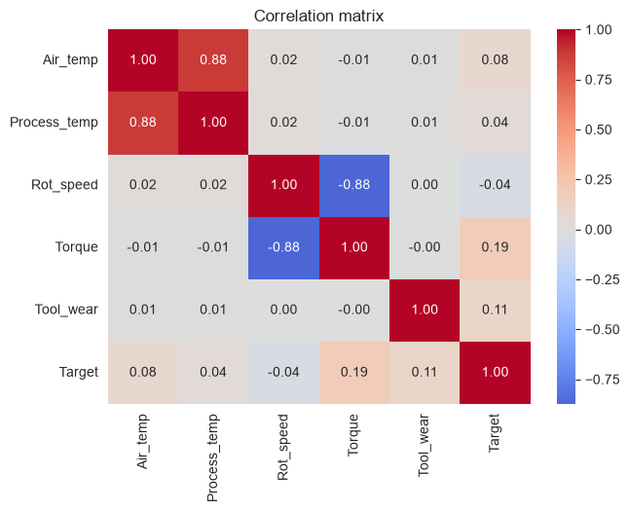  Figure 5: Correlation matrix | Key observations  - Air_temp and Process_temp are strongly correlated (0.88).  - Rot_speed and Torque are strongly negatively correlated (−0.88).  - Correlation of each reading with Target is weak: Torque 0.191, Tool_wear 0.105, Air_temp 0.083, Process_temp 0.036, Rot_speed −0.044.  - Weak linear correlation suggests that failures depend on combinations of readings rather than on one reading alone.

Justification: The strong correlations are expected from how the machine behaves (process temperature follows air temperature, and speed falls as torque rises at roughly constant power). With only five numeric readings no feature is removed; tree-based models handle correlated inputs well. The weak individual correlations motivate both the engineered features and the use of non-linear tree models.

9. Feature Engineering and Feature Selection

9.1 Feature engineering
Each raw reading is only weakly correlated with failure, but failures in a machine arise from combinations of readings. Three features were created from the raw values (before any transformation):
- Temp_diff = Process_temp − Air_temp, a measure of how well the machine dissipates heat.
- Power = Torque × Rot_speed × 2π / 60 (watts), the mechanical power delivered.
- Torque_wear = Torque × Tool_wear, an indicator of overstrain on a worn tool.
Justification: These three quantities correspond to failure mechanisms described in the documentation of the original dataset: heat dissipation (temperature difference together with speed), power (outside a safe range) and overstrain (tool wear × torque above a limit). The outlier analysis supports this: rows with extreme Power or Torque_wear values failed 100% of the time (Section 10).

9.2 Do the engineered features help?
To confirm the value of the new features, five of the models were cross-validated twice, with and without them, using the same data split, pipeline and settings as the notebook.
Table 12: Cross-validation F1 (failure class) with and without engineered features – supporting experiment
Model | Raw features only (7) | With engineered features (10) | Gain
Logistic Regression | 0.217 | 0.270 | +0.053
SVM (RBF) | 0.417 | 0.451 | +0.034
Decision Tree | 0.538 | 0.611 | +0.073
Random Forest | 0.630 | 0.746 | +0.116
XGBoost | 0.688 | 0.796 | +0.108
The engineered features improved every model, most strongly the tree ensembles, which find it hard to build products of two readings by themselves. The “with engineered features” column equals the cross-validation results of the notebook.

9.3 Feature selection
Table 13: Feature selection decisions
Feature(s) | Decision | Justification
UDI, Product_ID | Dropped | Identifiers with no predictive meaning; they would encourage memorisation
Type | Kept – one-hot encoded as Type_L and Type_M | Failure rate differs by type (3.92% / 2.77% / 2.09%). Type has no numeric order, so it is one-hot encoded; drop_first removes the redundant H column
Air_temp, Process_temp, Rot_speed, Torque, Tool_wear | Kept | Raw sensor readings; they are the basis of the engineered features and show differences between failed and healthy machines
Temp_diff, Power, Torque_wear | Kept (new) | Capture physical failure mechanisms and improve all tested models (Section 9.2)
Target | Target variable | Label to be predicted (not used as an input)

Why no automatic feature selection: The final model has only 10 meaningful features, so methods such as PCA or recursive elimination would add complexity without a clear benefit. Correlated features were kept because removing them would discard information, and tree-based models ignore uninformative splits on their own. Final features: Air_temp, Process_temp, Rot_speed, Torque, Tool_wear, Temp_diff, Power, Torque_wear, Type_L, Type_M.

10. Skewness and Outlier Treatment

10.1 Skewness
A column is treated as noticeably skewed when its absolute skewness exceeds 0.75. Only Rot_speed (1.993) crosses this limit.
Table 14: Skewness before and after the log1p transformation
Feature | Skewness before | Skewness after | Transformed
Rot_speed | 1.993 | 1.310 | Yes
Torque_wear | 0.470 | 0.470 | No
Air_temp | 0.114 | 0.114 | No
Tool_wear | 0.027 | 0.027 | No
Process_temp | 0.015 | 0.015 | No
Power | 0.008 | 0.008 | No
Torque | −0.010 | −0.010 | No
Temp_diff | −0.072 | −0.072 | No
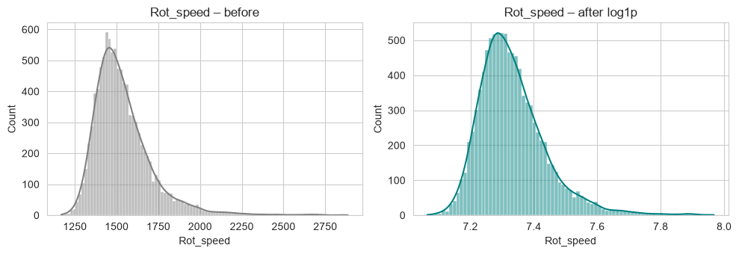
Figure 6: Rot_speed before and after the log1p transformation
Justification: log1p was chosen because it reduces right skew and is safe for zero values; the code checks that all values are non-negative first. A more symmetric input helps scale-sensitive models (Logistic Regression, SVM, KNN); tree models are not affected. The skew fell from 1.993 to 1.310 but not to zero, because the remaining tail consists of genuine high-speed readings (see below), which should not be distorted further.

10.2 Outliers
Outliers were counted with the IQR rule (values beyond 1.5 × IQR from the quartiles). Before removing anything, the failure rate inside the outlier rows was checked, because in predictive maintenance extreme readings are often the warning signs of failure.
Table 15: Outliers and the failure rate inside them (overall failure rate 3.39%)
Feature | Outliers | % of rows | Failure rate inside outliers
Air_temp | 0 | 0.00 | –
Process_temp | 0 | 0.00 | –
Rot_speed (after log1p) | 323 | 3.23 | 10.53%
Torque | 69 | 0.69 | 89.86%
Tool_wear | 0 | 0.00 | –
Temp_diff | 0 | 0.00 | –
Power | 60 | 0.60 | 100.00%
Torque_wear | 20 | 0.20 | 100.00%

Decision – outliers are kept: Rows with extreme Torque, Power or Torque_wear values failed 90–100% of the time, and extreme Rot_speed rows failed three times more often than average. These are genuine operating conditions that carry the failure signal. With only 339 failures, deleting rows would also remove valuable minority-class examples. Extreme values can affect scale-sensitive models, but those models are only comparison baselines; the final tree-based model is not sensitive to them.

11. Data Preparation for Modelling

11.1 Train/test split
The one-hot encoded data was split 80/20 with stratification (random_state = 42): the training set has 8,000 rows with 271 failures (3.39%) and the test set has 2,000 rows with 68 failures (3.40%). Type was encoded before the split; this is safe because encoding is a fixed rule that learns nothing from the data.
Table 16: Train/test split
Set | Rows | Failures | Failure rate
Training set | 8,000 | 271 | 3.39%
Test set | 2,000 | 68 | 3.40%
Justification: stratification keeps the rare failure class in the same proportion in both sets, so the test score is representative. The test set is used only once, for the final evaluation, and the fixed random_state makes the results reproducible.

11.2 Scaling
StandardScaler (mean 0, standard deviation 1) is used. Justification: Logistic Regression, KNN and SVM depend on feature scale, and the features are on very different scales (rotational speed in the thousands, temperature differences near 10). Scaling is fitted on training data only.

11.3 Class imbalance
The training set has 7,729 healthy and 271 failed records. SMOTE (Synthetic Minority Over-sampling Technique) creates new synthetic failure examples between existing neighbouring failures until both classes have 7,729 records.
Justification: With 3.4% failures a model can score well by favouring the majority class and miss real failures. Oversampling the minority class lets the model learn the failure pattern. SMOTE was preferred to simple duplication (which encourages memorisation) and to undersampling (which would discard most of the healthy examples). It is applied to training data only; the test data is never resampled.

11.4 Pipeline and prevention of data leakage
For every model the steps are chained as StandardScaler → SMOTE → model in one imbalanced-learn pipeline, evaluated with 5-fold stratified cross-validation (shuffle = True, random_state = 42). In each fold the scaler and SMOTE are fitted on the four training folds only, so no information from the validation fold leaks into training and every model is treated in exactly the same way.

11.5 Evaluation metrics
Table 17: Metrics used and why
Metric | Meaning (failure class) | Why it matters here
Precision | Of the machines predicted to fail, the share that really failed | Low precision means many false alarms and wasted maintenance
Recall | Of the machines that really failed, the share that was caught | Low recall means missed failures and unplanned downtime
F1 score | Balance of precision and recall | Main selection metric, because both errors are costly
ROC-AUC | Ability to rank failures above healthy machines | Threshold-independent overall quality
PR-AUC | Area under the precision–recall curve | More informative than ROC-AUC when the positive class is rare
Accuracy | Share of all correct predictions | Reported for reference only; 96.61% is reached by always predicting “no failure”

12. Model Development and Comparison

12.1 Models created
Nine supervised classification algorithms from different families were trained so that the comparison is fair and broad, as required by the project objective.
Table 18: Algorithms compared
Algorithm | Family | Configuration | Reason for inclusion
Logistic Regression | Linear | max_iter = 2000 | Simple, interpretable baseline
KNN | Distance-based | k = 5 | Non-parametric baseline
Naive Bayes | Probabilistic | Gaussian | Very fast baseline
Decision Tree | Tree | Default settings | Captures non-linear threshold rules; easy to interpret
Random Forest | Bagging ensemble | 200 trees | Reduces the variance of a single tree
AdaBoost | Boosting ensemble | 200 estimators | Focuses on hard-to-classify cases
Gradient Boosting | Boosting ensemble | Default settings | Strong tabular-data learner
SVM (RBF) | Kernel method | RBF kernel | Non-linear decision boundary
XGBoost | Boosting ensemble | 300 trees, learning rate 0.1 | Regularised, efficient gradient boosting

12.2 Cross-validation results
Table 19: 5-fold cross-validation on the training set (failure class), sorted by F1
Model | Precision | Recall | F1 | F1 std. | ROC-AUC | PR-AUC
XGBoost | 0.745 | 0.856 | 0.796 | 0.032 | 0.977 | 0.893
Random Forest | 0.671 | 0.841 | 0.746 | 0.033 | 0.978 | 0.863
Decision Tree | 0.493 | 0.805 | 0.611 | 0.034 | 0.888 | 0.404
Gradient Boosting | 0.407 | 0.900 | 0.559 | 0.024 | 0.982 | 0.883
AdaBoost | 0.364 | 0.904 | 0.518 | 0.017 | 0.973 | 0.772
KNN | 0.334 | 0.764 | 0.464 | 0.024 | 0.895 | 0.396
SVM (RBF) | 0.306 | 0.860 | 0.451 | 0.017 | 0.963 | 0.701
Logistic Regression | 0.162 | 0.812 | 0.270 | 0.006 | 0.922 | 0.443
Naive Bayes | 0.155 | 0.849 | 0.261 | 0.018 | 0.920 | 0.537
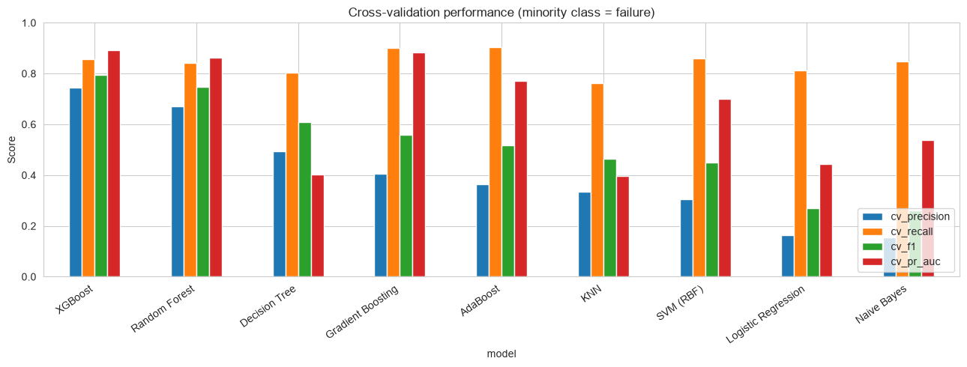
Figure 7: Cross-validation performance of the nine models
XGBoost has the best F1 (0.796) and PR-AUC (0.893). AdaBoost and Gradient Boosting reach a higher recall (0.904 and 0.900) but with low precision (0.364 and 0.407), meaning many false alarms. Justification for choosing by F1 and PR-AUC: both missed failures and false alarms are costly, so a metric that balances precision and recall is the fair criterion.

12.3 Test-set results
All models were refitted on the full training set and scored on the unseen test set.
Table 20: Hold-out test set results (failure class), sorted by F1
Model | Accuracy | Precision | Recall | F1 | ROC-AUC | PR-AUC
XGBoost | 0.979 | 0.651 | 0.824 | 0.727 | 0.980 | 0.867
Random Forest | 0.973 | 0.570 | 0.838 | 0.679 | 0.981 | 0.851
Decision Tree | 0.966 | 0.500 | 0.838 | 0.626 | 0.904 | 0.425
Gradient Boosting | 0.948 | 0.387 | 0.882 | 0.538 | 0.978 | 0.862
AdaBoost | 0.941 | 0.356 | 0.912 | 0.512 | 0.971 | 0.776
SVM (RBF) | 0.927 | 0.305 | 0.897 | 0.455 | 0.972 | 0.660
KNN | 0.936 | 0.315 | 0.765 | 0.446 | 0.906 | 0.374
Logistic Regression | 0.864 | 0.185 | 0.882 | 0.305 | 0.938 | 0.426
Naive Bayes | 0.845 | 0.168 | 0.897 | 0.282 | 0.926 | 0.459
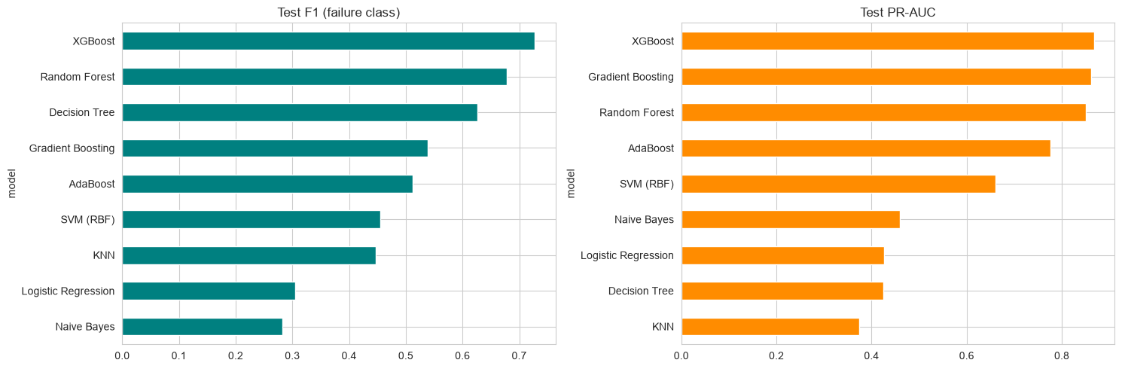
Figure 8: Test F1 and PR-AUC of the nine models
The ranking on the test set is almost identical to the cross-validation ranking (only KNN and SVM swap places), and XGBoost is again first. This agreement shows that the model choice is not an accident of one particular split.

13. Overfitting Analysis and Treatment

13.1 Overfitting check
Overfitting was checked by comparing the F1 score on the training data, in cross-validation and on the test set. A model is flagged as overfitted when the train − test gap is larger than 0.10.
Table 21: Train, cross-validation and test F1
Model | Train F1 | CV F1 | Test F1 | Gap (train − test) | Overfitted?
Decision Tree | 1.000 | 0.611 | 0.626 | 0.374 | Yes
Random Forest | 1.000 | 0.746 | 0.679 | 0.321 | Yes
XGBoost | 1.000 | 0.796 | 0.727 | 0.273 | Yes
KNN | 0.621 | 0.464 | 0.446 | 0.175 | Yes
Gradient Boosting | 0.625 | 0.559 | 0.538 | 0.087 | No
SVM (RBF) | 0.505 | 0.451 | 0.455 | 0.050 | No
AdaBoost | 0.544 | 0.518 | 0.512 | 0.032 | No
Naive Bayes | 0.260 | 0.261 | 0.282 | −0.022 | No
Logistic Regression | 0.279 | 0.270 | 0.305 | −0.026 | No
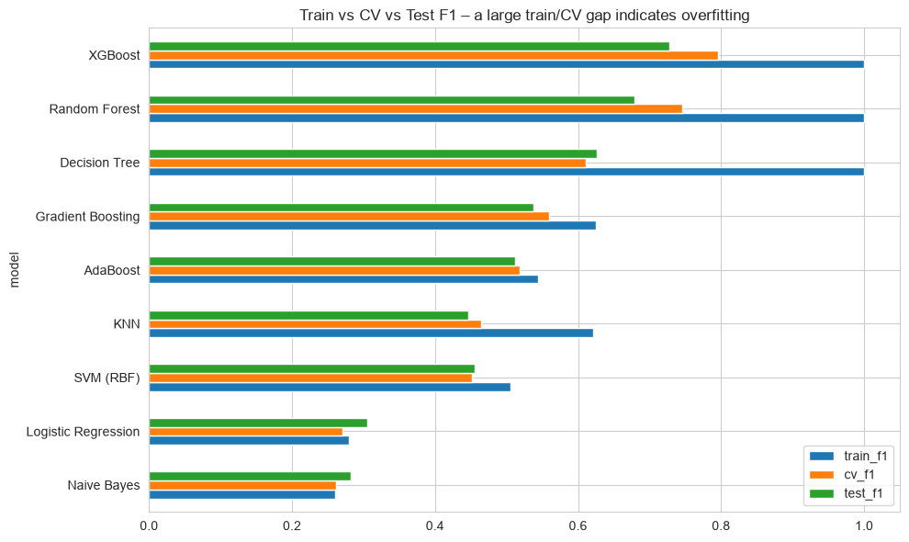
Figure 9: Train, cross-validation and test F1 for each model
The tree-based models memorise the training data (train F1 close to 1.0). Logistic Regression and Naive Bayes show no gap, but only because they underfit: their F1 is low everywhere. A small gap is therefore not enough; the score on unseen data matters most.

13.2 Treatment: hyper-parameter tuning
XGBoost, the best model in cross-validation, was tuned with GridSearchCV (5-fold, scoring F1) over 12 combinations: max_depth {3, 4, 6} × n_estimators {300, 500} × learning_rate {0.1, 0.2}. The best settings were learning_rate = 0.2, max_depth = 4, n_estimators = 300, with a cross-validation F1 of 0.809 (default: 0.796).
Justification: Shallower trees (max_depth) are simpler and memorise less. The grid includes the default settings, so tuning cannot do worse than the default in cross-validation. The settings were chosen with cross-validation on the training data and not with the test set, which would leak test information into the model.
Table 22: Effect of tuning, and a stronger-regularisation experiment
XGBoost version | Train F1 | CV F1 | Test F1 | Gap (train − test)
Default settings | 1.000 | 0.796 | 0.727 | 0.273
Tuned (selected) | 0.996 | 0.809 | 0.775 | 0.222
Heavily regularised (experiment) | 0.552 | 0.535 | 0.521 | 0.031
Tuning reduced the gap by 0.051 and raised the test F1 by 0.048. A gap of 0.222 remains, so some overfitting is still present. A supporting experiment with a much simpler XGBoost (depth 3, small learning rate, strong penalties) almost closed the gap (0.031) but lowered the F1 to about 0.52, i.e. the model then underfits. Justification for accepting the remaining gap: the tuned model has the best cross-validation and test scores of all options, and further regularisation costs more performance than it gains.

14. Final Model Selection and Evaluation

14.1 Why XGBoost was chosen
Table 23: Selection criteria and evidence
Criterion | Evidence
Best cross-validation F1 | XGBoost 0.796 (tuned 0.809); next best Random Forest 0.746
Best test F1 | XGBoost 0.727 (tuned 0.775); next best Random Forest 0.679
Best PR-AUC (most suitable for rare events) | Cross-validation 0.893 and test 0.867, the highest of all nine models
Balanced precision and recall | Precision 0.745 and recall 0.856 in cross-validation; models with higher recall have far lower precision
Consistency | Same ranking in cross-validation and on the test set
Practicality | Handles non-linear interactions and correlated inputs, needs no feature-scale assumptions and is quick to train and to serve

14.2 Final evaluation on the test set
The tuned XGBoost model was evaluated once on the 2,000 unseen test records.
Table 24: Final model – classification report on the test set
Class | Precision | Recall | F1 | Support
No failure (0) | 0.99 | 0.99 | 0.99 | 1,932
Failure (1) | 0.74 | 0.81 | 0.77 | 68
Accuracy |  |  | 0.98 | 2,000
Macro average | 0.87 | 0.90 | 0.88 | 2,000
Weighted average | 0.98 | 0.98 | 0.98 | 2,000
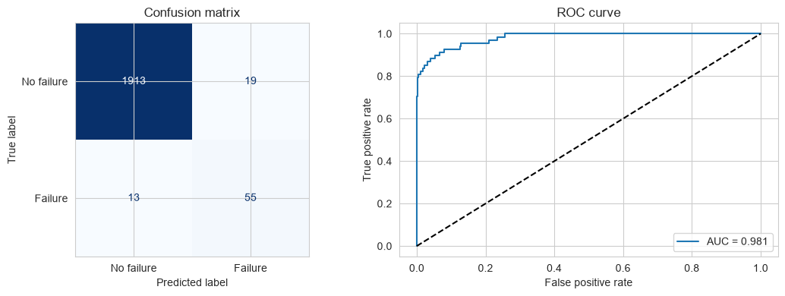
Figure 10: Confusion matrix and ROC curve of the final model (ROC-AUC 0.981)
Overall accuracy is 0.984, precision 0.743, recall 0.809, F1 0.775 and ROC-AUC 0.981. Interpretation: the model detects 55 of the 68 real failures (80.9%) and misses 13. Of the 74 machines it flags, 55 really fail (74.3%), and 19 healthy machines are flagged by mistake, a false-alarm rate of only 0.98% (19 of 1,932). Accuracy of 98.4% is also clearly above the 96.6% of the “always no failure” baseline.

15. Model Deployment
The final model was saved with pickle in predictive_maintenance_model.pkl so that it can be used by a Streamlit web application (app.py).
- What is saved: a dictionary with the fitted model, the list of feature columns in the exact training order and the list of log-transformed columns.
- SMOTE is not saved. Only the fitted StandardScaler and XGBoost model are stored as a plain scikit-learn pipeline, because SMOTE is used for training only and is never applied to new data. This makes the saved model simpler and removes the need for the imbalanced-learn library when predicting.
- Same preparation for new data: a function (prepare_input) repeats feature engineering, the log1p transformation and the one-hot encoding in the same order as in training.
- Verification: raw test records passed through prepare_input gave data identical to X_test and identical predictions (both checks returned True), which proves that the application prepares data exactly as the notebook did.
- Application: the user enters the machine type and five readings; the app shows whether the machine is likely to fail and a failure score. Example: type L, air 300 K, process 310 K, 1,400 rpm, torque 65 Nm and tool wear 200 min gives a failure score of 100%.
The score is the model’s confidence and not a calibrated real-world probability; a score above 50% is predicted as failure.

16. Limitations
- The dataset is synthetic; performance on real machines may differ and would require retraining on real data.
- There are only 339 failures (68 in the test set), so the test metrics carry uncertainty; a few records can move F1 by several points.
- Some overfitting remains (train F1 0.996 vs test F1 0.775).
- SMOTE creates synthetic data; the model is not trained on additional real failures.
- The default decision threshold of 0.5 treats missed failures and false alarms as equally costly.

17. Conclusion
This project built a classifier that predicts machine failure from sensor data. After checking data quality, exploring the data and engineering three physically meaningful features, the data was split in a stratified way and prepared with scaling and SMOTE inside a leakage-safe pipeline. Nine supervised algorithms were compared with 5-fold cross-validation; XGBoost was the best and, after tuning with GridSearchCV (learning_rate 0.2, max_depth 4, n_estimators 300), reached on the unseen test set an accuracy of 0.984, precision of 0.743, recall of 0.809, F1 of 0.775 and ROC-AUC of 0.981. Overfitting was measured and reduced but not eliminated, and the trade-off was explained. The model was saved and made available through a Streamlit application. Every step of the work is justified in this document and summarised in Appendix A.

Appendix A: Step-by-Step Justification Summary
# | Step | What was done | Justification and evidence
1 | Load and rename | read_csv; shorter column names | Clean names; XGBoost rejects brackets in feature names
2 | Quality checks | Nulls, duplicates, types, statistics | No missing values or duplicates, so no cleaning needed
3 | Drop identifiers | UDI and Product_ID removed | Unique per row; no predictive value; avoids memorisation
4 | EDA | Target, type, distributions, box plots, correlations | Found 3.39% failures, higher torque and wear in failures, weak linear correlations
5 | Feature engineering | Temp_diff, Power, Torque_wear | Match physical failure mechanisms; CV F1 up to +0.116
6 | Skewness | log1p on Rot_speed | Skewness 1.993 → 1.310; helps scale-sensitive models
7 | Outliers | IQR analysis; outliers kept | Outliers fail 90–100% of the time; only 339 failures
8 | Encoding | One-hot Type_L, Type_M (drop_first) | No natural order in Type; no redundant column
9 | Train/test split | Stratified 80/20, random_state 42 | Keeps 3.4% failure rate in both sets; reproducible
10 | Scaling | StandardScaler inside the pipeline | Needed by LR, KNN, SVM; fitted on training data only
11 | Class imbalance | SMOTE on training folds only | Failures 271 → 7,729 in training; no leakage into test
12 | Model comparison | 9 algorithms, 5-fold stratified CV | XGBoost best: F1 0.796, PR-AUC 0.893
13 | Test evaluation | All models on the hold-out set | Ranking matches cross-validation
14 | Overfitting check | Train / CV / test F1 gap | Decision Tree, Random Forest, XGBoost, KNN flagged (gap > 0.10)
15 | Tuning | GridSearchCV, 12 combinations, F1 | CV F1 0.809; test F1 0.727 → 0.775; gap 0.273 → 0.222
16 | Final evaluation | Report, confusion matrix, ROC | Precision 0.743, recall 0.809, F1 0.775, ROC-AUC 0.981
17 | Deployment | Pickle (scaler + XGBoost), Streamlit app | Predictions identical to the notebook; SMOTE not needed at prediction time

Appendix B: Glossary of Terms
Term | Meaning in this project
Binary classification | Predicting one of two classes; here failure (1) or no failure (0)
Class imbalance | One class is much rarer than the other; here only 3.39% of machines fail
SMOTE | Synthetic Minority Over-sampling Technique: creates new synthetic examples of the rare class by interpolating between neighbouring real examples
Stratified split | A split that keeps the class proportions the same in the training and test sets
Cross-validation (5-fold) | The training data is divided into 5 parts; the model is trained on 4 and validated on 1, five times, and the scores are averaged
Pipeline | A chain of steps (scaling, SMOTE, model) applied in a fixed order so that each step learns only from training data
Data leakage | Information from the validation or test data influencing training, which gives unrealistically good scores
Overfitting | The model memorises the training data and performs clearly worse on unseen data
Underfitting | The model is too simple and performs poorly on both training and unseen data
Precision | Of the machines predicted to fail, the share that really failed
Recall | Of the machines that really failed, the share the model caught
F1 score | The balance (harmonic mean) of precision and recall
ROC-AUC | How well the model ranks failed machines above healthy ones (1.0 = perfect, 0.5 = random)
PR-AUC | Area under the precision–recall curve; more informative than ROC-AUC for rare events
Hyper-parameter | A model setting chosen before training, such as max_depth or learning_rate
GridSearchCV | Tries every combination of the listed hyper-parameter values with cross-validation and keeps the best
One-hot encoding | Turns a category (L, M, H) into separate 0/1 columns
log1p | The transformation log(1 + x), used to reduce right skew
IQR rule | Flags values more than 1.5 × the interquartile range beyond the quartiles as outliers

